AI56
Acoustic imaging camera

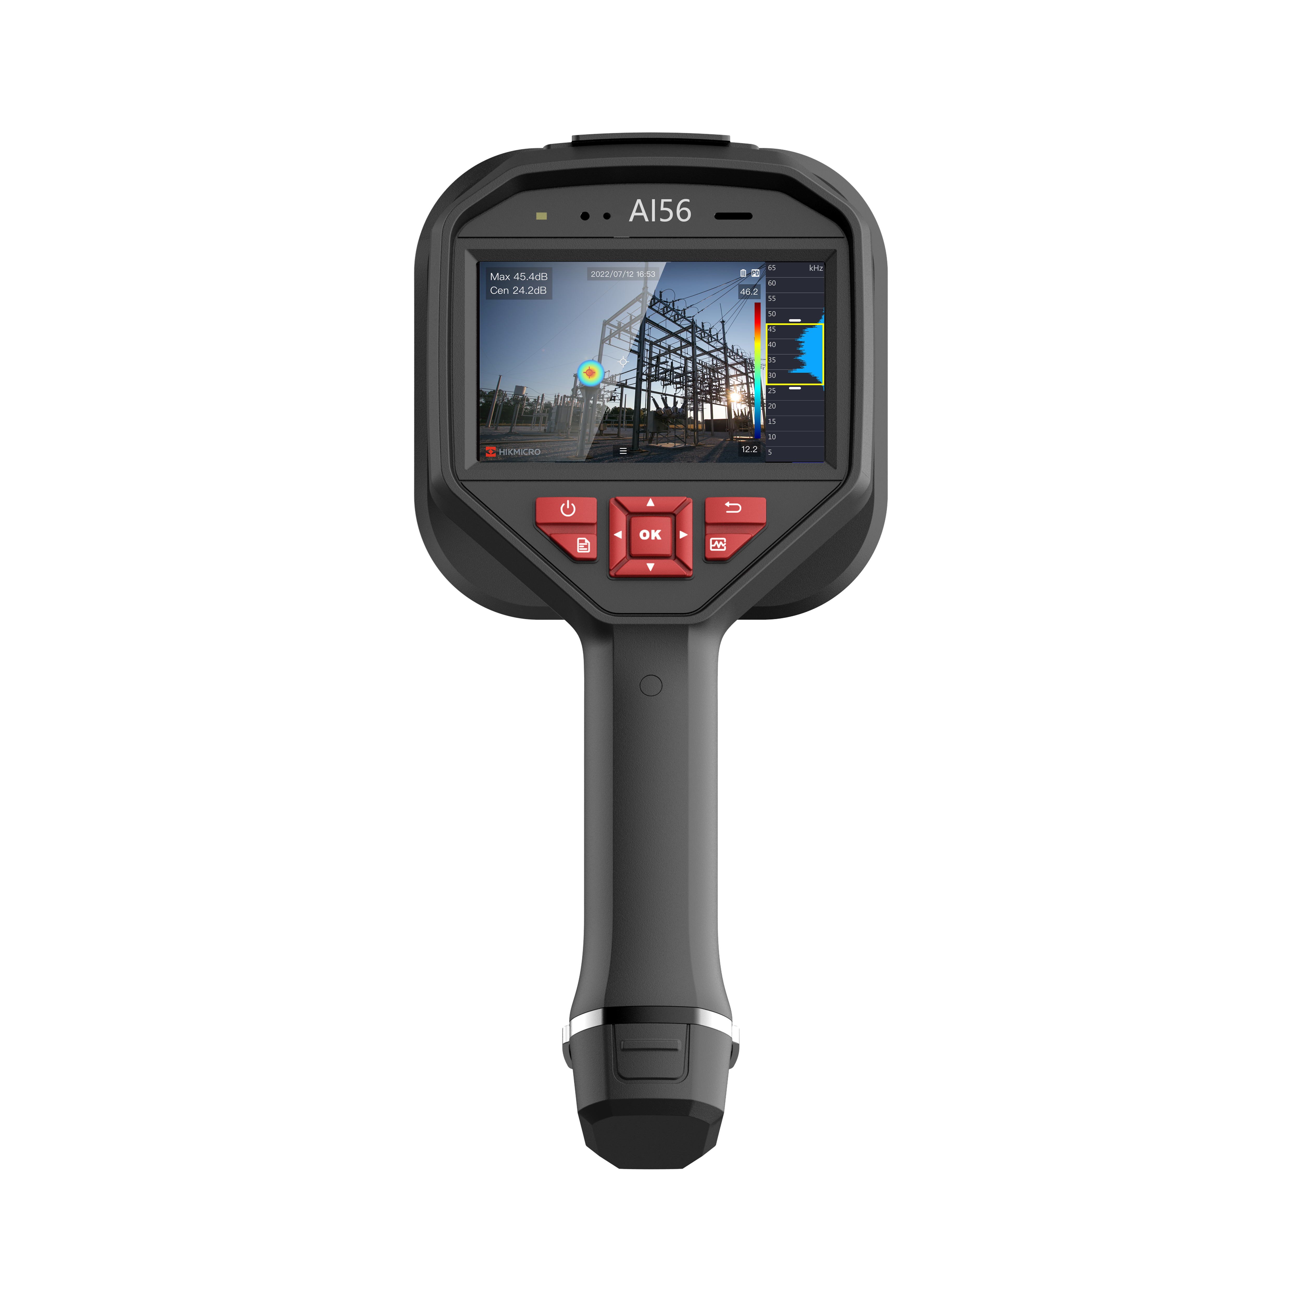

The HIKMICRO AI56 acoustic imaging camera is a professional product for gas leak detection and partial discharge detection. With 64 Low-noise MEMS microphones and an adjustable bandwidth range from 2 kHz to 65 kHz, AI56 provides an easy and effective way to locate pressurized air leaks in industrial environments or detect partial discharge in electric systems. By adopting this lightweight and easy-to-use tool, you can discover potential safety risks, minimize troubleshooting, and save extra costs for equipment failures and downtime.

Key Features
- 64 Low-noise MEMS Microphones, real-time sound source localization
- Real-time estimated leak rate, leak cost, and leak level for gas leak detection
- Partial discharge detection can identify corona, floating, surface, and particle discharges
- Analyzer acoustic software for analyzing images and export reports.
- 800 × 480 Resolution, 4.3’LCD Touch Screen
- Supports 8 acoustic palettes

- Specification
Acoustic
Number of Microphones | 64
Acoustic Image Resolution | 800 × 480
Bandwidth | 2kHz~65kHz
Distance | 0.3m~100m
Acoustic Image Palette | 8: White Black, Black White, Rainbow, Fusion, Ironbow, Red Black, Rain, Blue Red
Camera FOV | 50.2°× 35.4°
Sound Intensity Display | Peak Point
Acoustic Image Frame Rate | 25 fps
Dynamic Range | Low Limit: <-15dB  High Limit: >120dB
Leak Rate | >0.008 l/min @ 6 bar from 0.5 m (1.64 ft)  >0.013 l/min @ 5 bar from 1 m (3.28 ft)
Discharge Detection | Automatic detection 50 / 60 Hz
Discharge Type | Corona Discharge, Particle Discharge, Floating Discharge, Surface Discharge
Image Display
Display | 800 × 480 Resolution, 4.3’LCD Touch Screen
Screen Brightness | Manual/Auto
Digital Zoom | 1.0x to 8.0x continuous
Data Storage and Communication
Storage Media | Removable 64 GB SD Card
Image Storage Capacity | 20,000 images
Annotations | Voice note: max. 60 seconds;  Text note: max. 200 characters
Video Storage Capacity | 60 hours
Video File Format | MP4
General
Wi-Fi | 802.11 b/g/n (2.4 GHz and 5 GHz), Hot Spot only
Bluetooth | Bluetooth 4.1
USB Interface | USB Type-C
HDMI Interface | HDMI-D
Battery Operating Time | Approx. 3.5 hours
Battery Type | Dismountable and Rechargeable Li-ion Battery
Battery Charging Time | 5 hours to full charge
Protection level | IP40
Power Supply | 5V DC/2A (Charging via USB)
Drop Test Height | 1.2 m (3.94 ft)
Safety | IEC 61010-1
EMC | EN 55032, EN 50130-4, EN IEC 61000-3-2, EN 61000-3-3
Working Temperature Range | -20 °C to 50 °C (-4 °F to 122 °F)
Storage Temperature Range | -20 °C to 60 °C (-4 °F to 140 °F)
Relative Humidity | ＜95 % non-condensing
Weight | Approx. 940 g (2.07 lb)
Dimension | 292.2 × 127 × 110.7 mm (11.50 × 5.00 × 4.36 in)
Tripod Mounting | UNC ¼”-20

- Available Model
AI56

- Dimension
